PT Activity 7.5.3: Troubleshooting Wireless WRT300N (Solution)

Topology Diagram

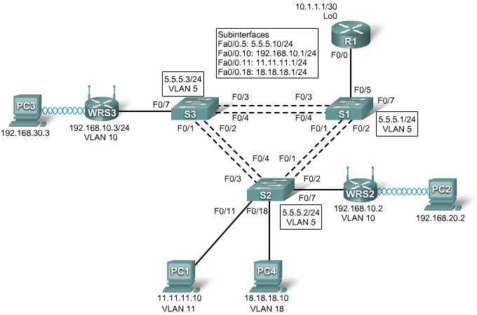

Addressing Table
Device | Interface | IP Address | Subnet Mask | Default Gateway
R1 | Fa0/0.5 | 5.5.5.10 | 255.255.255.0 | N/A
R1 | Fa0/0.10 | 192.168.10.1 | 255.255.255.0 | N/A
R1 | Fa0/0.11 | 11.11.11.1 | 255.255.255.0 | N/A
R1 | Fa0/0.18 | 18.18.18.1 | 255.255.255.0 | N/A
R1 | Lo0 | 10.1.1.1 | 255.255.255.252 | N/A
WRS2 | WAN | 192.168.10.2 | 255.255.255.0 | 192.168.10.1
WRS2 | LAN/Wireless | 192.168.20.1 | 255.255.255.0 | N/A
WRS3 | WAN | 192.168.10.3 | 255.255.255.0 | 192.168.10.1
WRS3 | LAN/Wireless | 192.168.30.1 | 255.255.255.0 | N/A
PC1 | NIC | 11.11.11.10 | 255.255.255.0 | 11.11.11.1
PC4 | NIC | 18.18.18.10 | 255.255.255.0 | 18.18.18.1
S1 | VLAN 5 | 5.5.5.1 | 255.255.255.0 | N/A
S2 | VLAN 5 | 5.5.5.2 | 255.255.255.0 | N/A
S3 | VLAN 5 | 5.5.5.3 | 255.255.255.0 | N/A

Learning Objectives
- Troubleshoot the network.
- Verify connectivity.

Scenario
In this activity, a basic network and wireless network have been configured improperly. You must find and correct the misconfigurations based on the minimum network specifications provided by your company.
Task 1: Troubleshoot the Network
Examine the routers and switches; determine any errors in the network.
Note: Packet Tracer will not grade the allowed VLANs for trunking mode.
The wireless routing requirements are as follows:
- Connections via the IP addresses shown in the topology diagram.
- 30 clients can get an IP address through DHCP at a single time.
- Wireless clients must be authenticated using WEP with a key of 5655545251.
- Ping requests coming from outside WAN ports of the Linksys routers to their inside LAN/wireless IP addresses (192.168.30.1) must be successful.
- DHCP must assign PC2 and PC3 their proper IP addresses.

Errors are:

PC2
Wireless WEP key = 5655545251

PC3
Wireless WEP key = 5655545251

R1
Port Fa0/0.10
IP address = 192.168.10.1/24
Port Fa0/0.11
VLAN 11 with 802.1Q encapsulation
IP address = 11.11.11.1/24

S1
Should have VLAN 18

S2
Port Fa0/1 should be a trunk port
Port Fa0/2 should be a trunk port

Port Fa0/3 should be a trunk port
Port Fa0/4 should be a trunk port
Port Fa0/7
Access port
VLAN 10
Port Fa0/11 should have port security enabled
Port Fa0/18
Port security
Sticky MAC of 00D0.BA7A.299D
(Note: Must remove the current sticky MAC address.)

S3
Port Fa0/7
Access port
VLAN 10
Interface VLAN 5 should have IP address 5.5.5.3/24

WRS2
Default Gateway = 192.168.10.1
DHCP
Max addresses = 30
Start IP = 192.168.20.2
Internet Port IP = 192.168.10.2
Wireless WEP key 5655545251

WRS3
Internet Port IP = 192.168.10.3
Task 2: Verify Connectivity
Due to a bug, Packet Tracer does not allow for PC2 and PC3 to ping one another, however connectivity should exist in all other circumstances. If they do not, continue troubleshooting. All the PCs should be able to ping one another and R1. Your completion result should be 100%. If not, continue troubleshooting.

